D:\test\Basic_ML>git clone https://github.com/mungekarkiran/machine_learning_project_test1.git

Cloning into 'machine_learning_project_test1'...

remote: Enumerating objects: 5, done.

remote: Counting objects: 100% (5/5), done.

remote: Compressing objects: 100% (5/5), done.

remote: Total 5 (delta 0), reused 0 (delta 0), pack-reused 0

Unpacking objects: 100% (5/5), done.

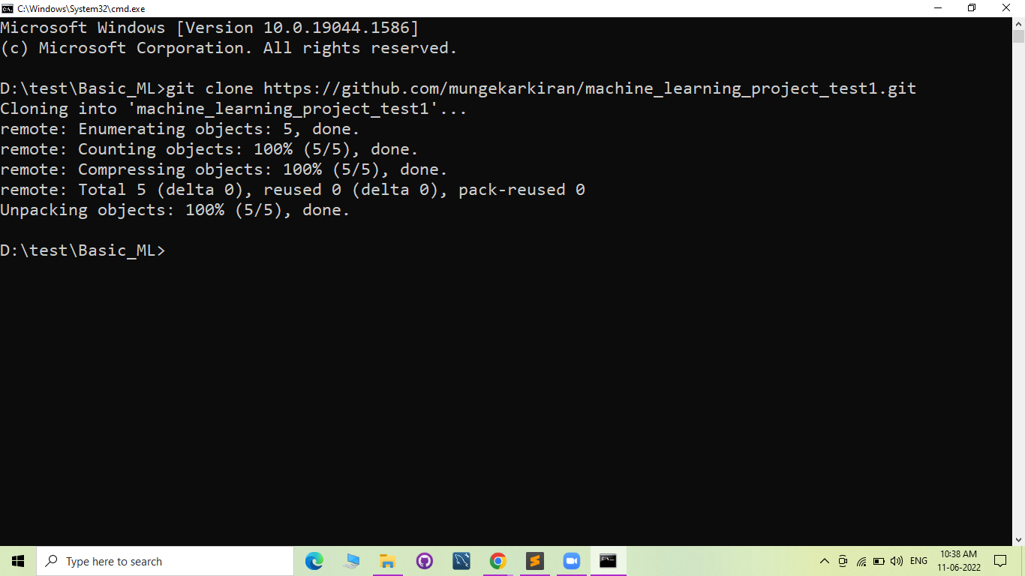

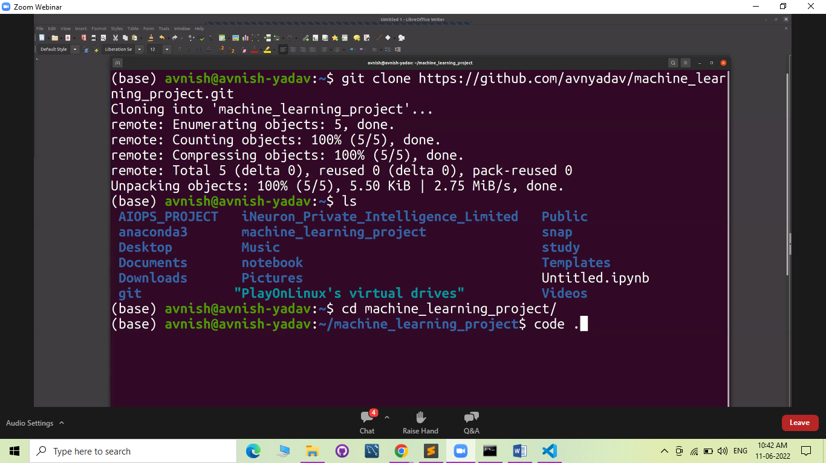

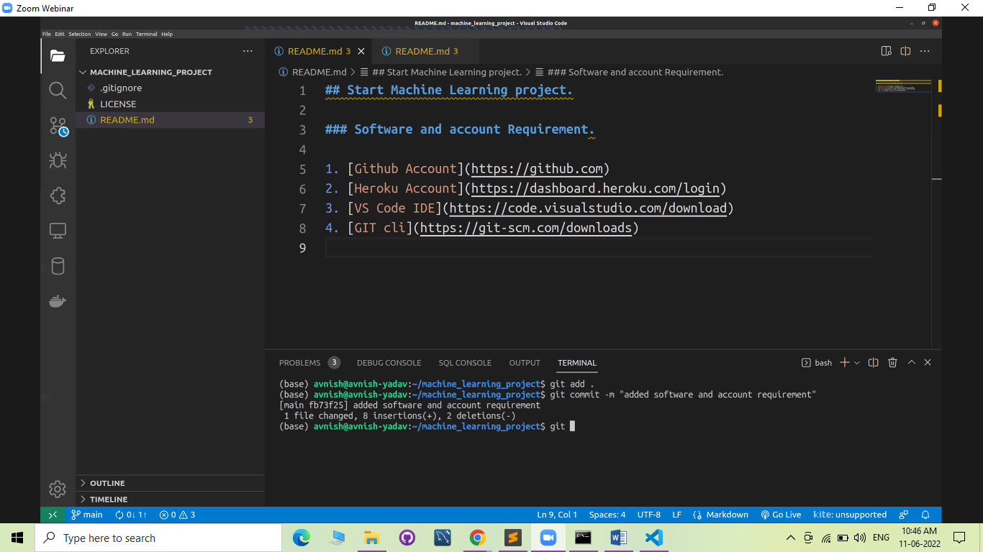

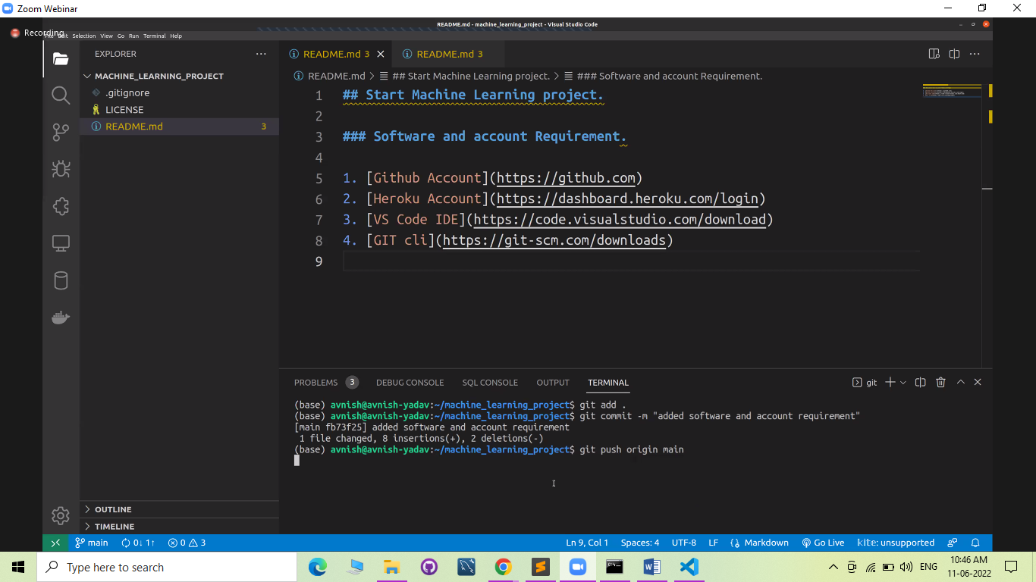

PS D:\test\Basic_ML\machine_learning_project_test1> git --version

git version 2.21.0.windows.1

PS D:\test\Basic_ML\machine_learning_project_test1> git add .

PS D:\test\Basic_ML\machine_learning_project_test1> git commit -m 'add required links'

[main 8a8fea4] add required links

1 file changed, 7 insertions(+)

PS D:\test\Basic_ML\machine_learning_project_test1> git push origin main

Enumerating objects: 5, done.

Counting objects: 100% (5/5), done.

Delta compression using up to 4 threads

Compressing objects: 100% (3/3), done.

Writing objects: 100% (3/3), 454 bytes | 454.00 KiB/s, done.

Total 3 (delta 1), reused 0 (delta 0)

remote: Resolving deltas: 100% (1/1), completed with 1 local object.

To https://github.com/mungekarkiran/machine_learning_project_test1.git

01a4c15..8a8fea4 main -> main

PS D:\test\Basic_ML\machine_learning_project_test1>

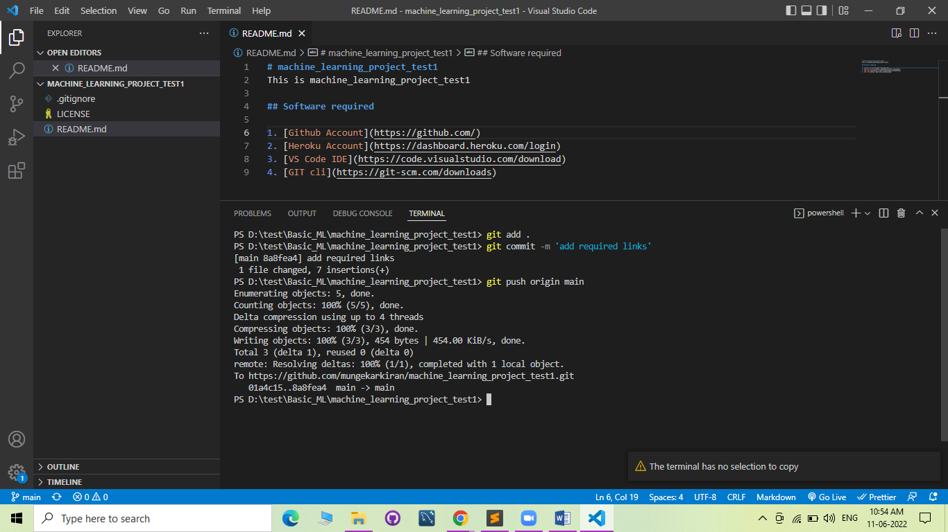

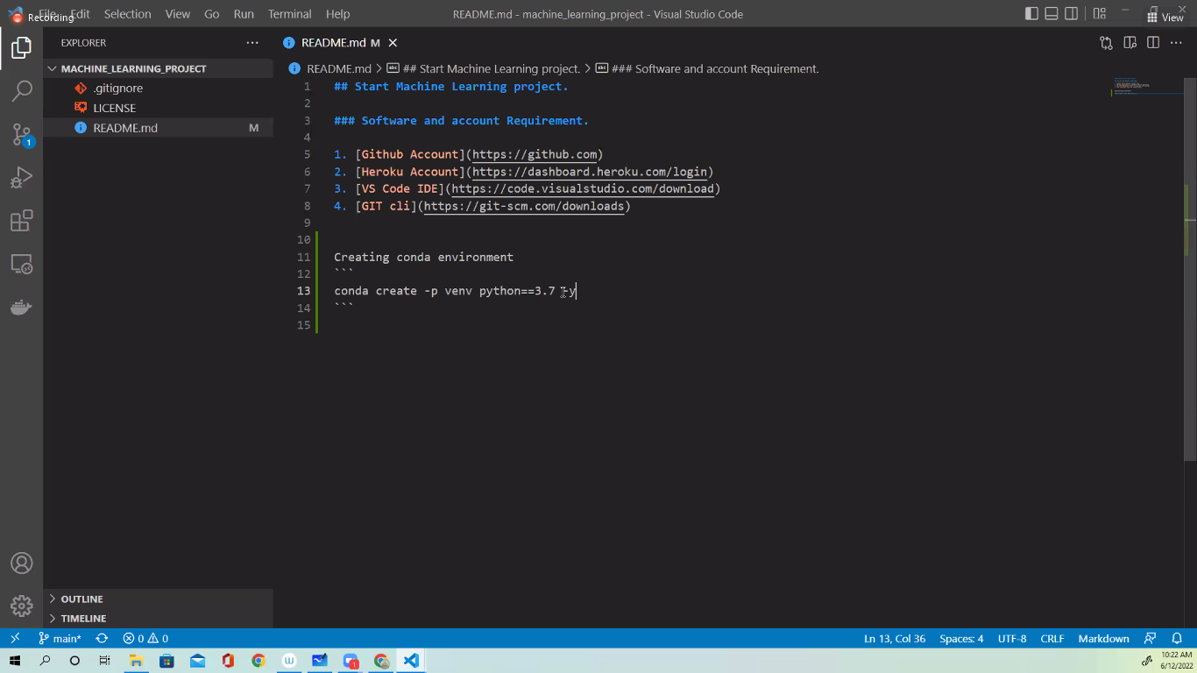

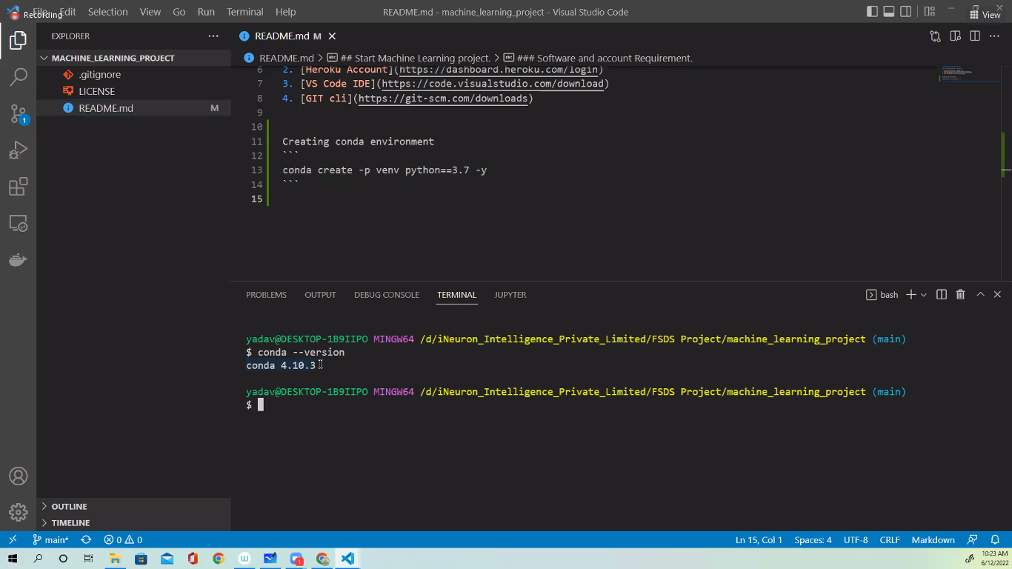

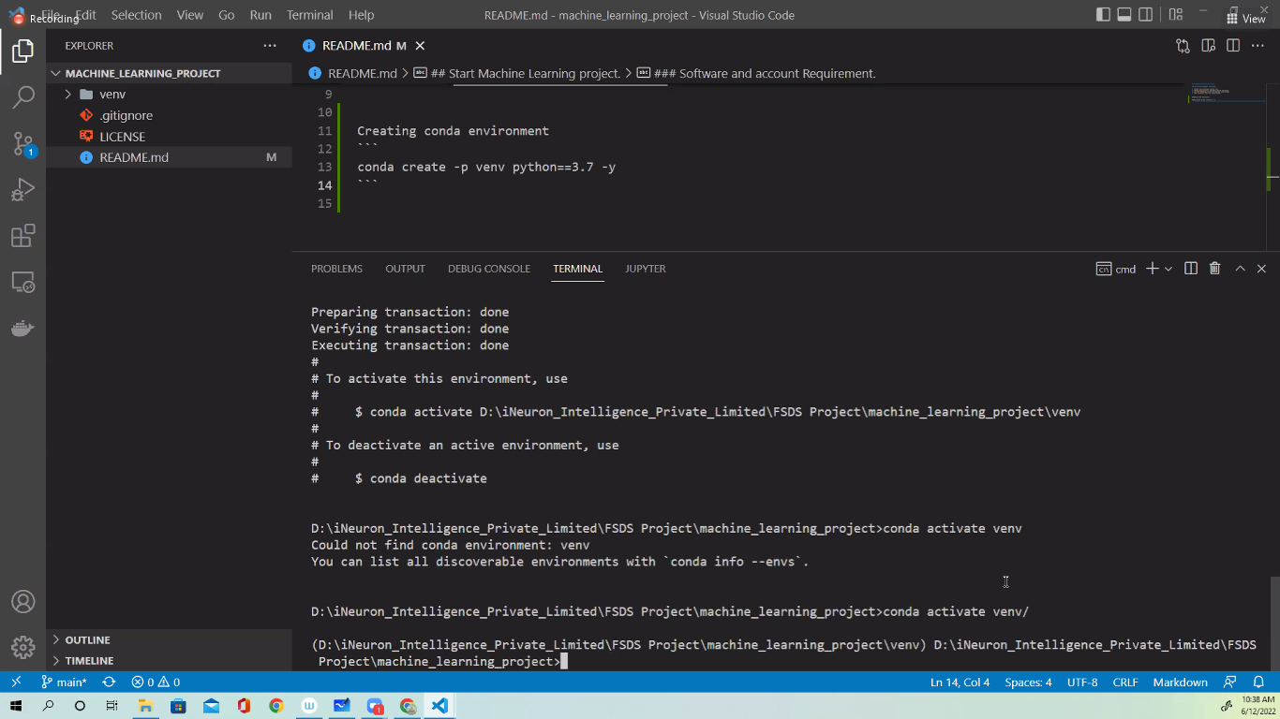

PS D:\test\Basic_ML\machine_learning_project_test1> git status

On branch main

Your branch is up to date with 'origin/main'.

Changes not staged for commit:

(use "git add/rm <file>..." to update what will be committed)

(use "git checkout -- <file>..." to discard changes in working directory)

modified: README.md

deleted: requirment.txt

Untracked files:

(use "git add <file>..." to include in what will be committed)

app.py

requirement.txt

no changes added to commit (use "git add" and/or "git commit -a")

PS D:\test\Basic_ML\machine_learning_project_test1>

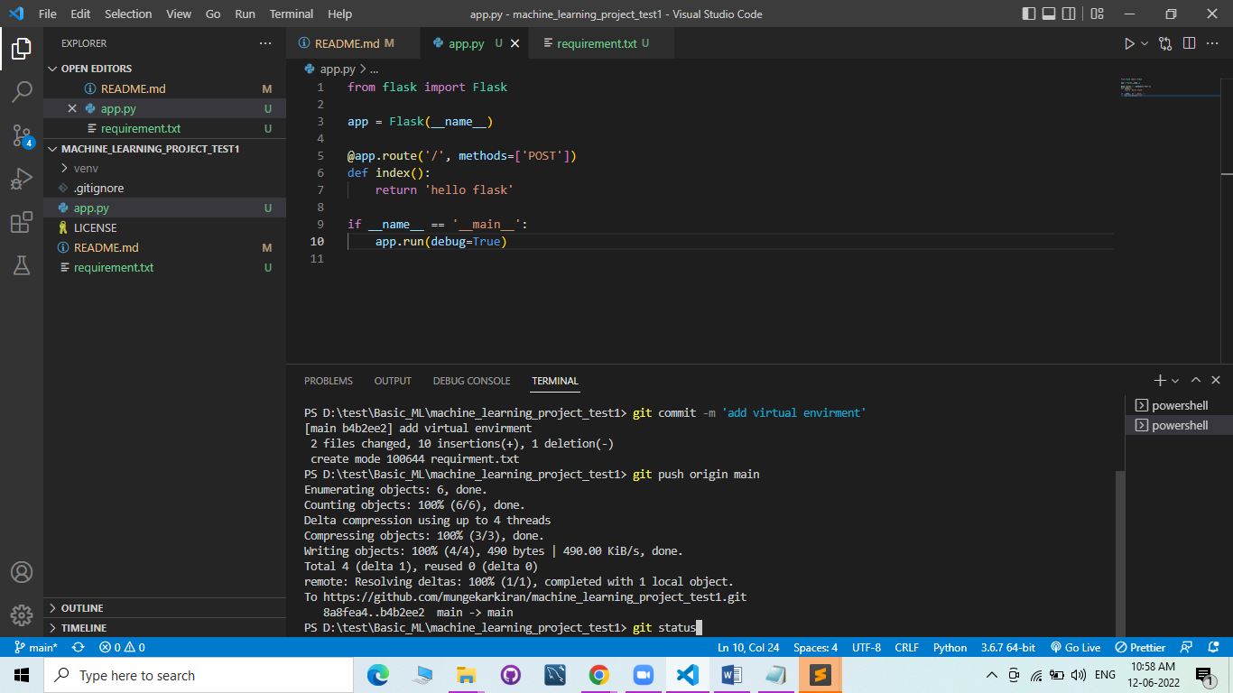 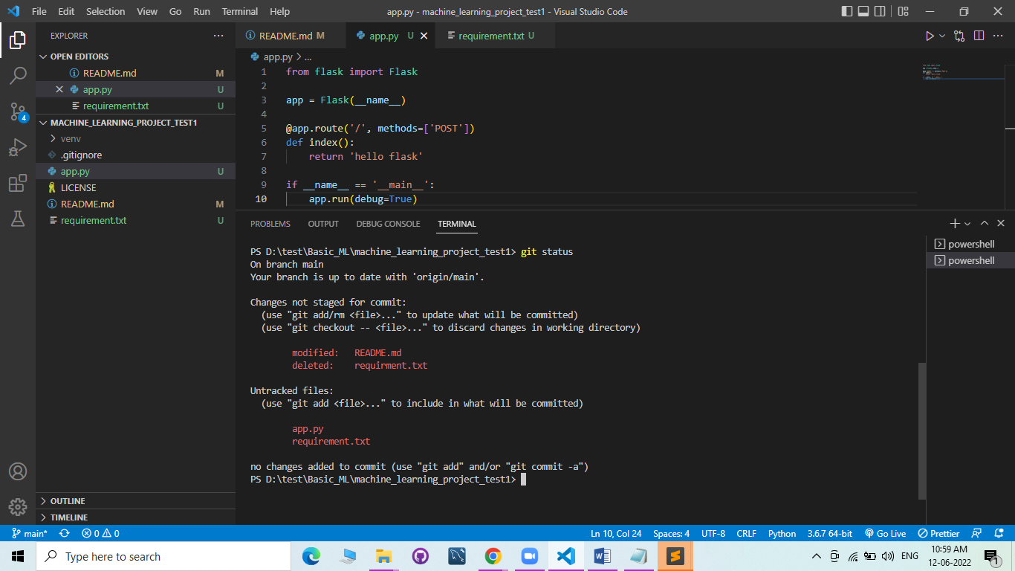

PS D:\test\Basic_ML\machine_learning_project_test1> git add app.py

PS D:\test\Basic_ML\machine_learning_project_test1> git status

On branch main

Your branch is up to date with 'origin/main'.

Changes to be committed:

(use "git reset HEAD <file>..." to unstage)

new file: app.py

Changes not staged for commit:

(use "git add/rm <file>..." to update what will be committed)

(use "git checkout -- <file>..." to discard changes in working directory)

modified: README.md

deleted: requirment.txt

Untracked files:

(use "git add <file>..." to include in what will be committed)

requirement.txt

PS D:\test\Basic_ML\machine_learning_project_test1>

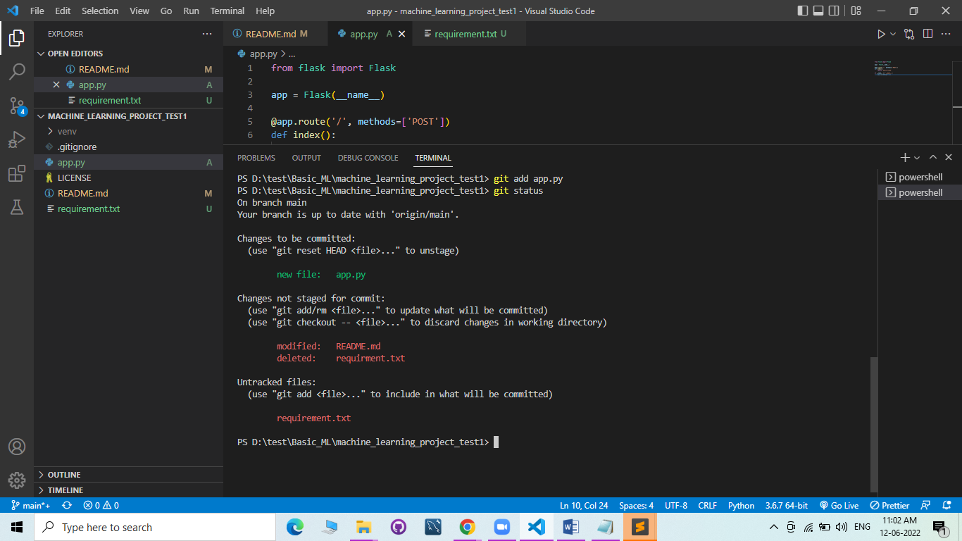

PS D:\test\Basic_ML\machine_learning_project_test1> git log

commit b4b2ee2c3d66db9bd7016deba196e936ff70b224 (HEAD -> main, origin/main, origin/HEAD)

Author: mungekarkiran <73243176+mungekarkiran@users.noreply.github.com>

Date: Sun Jun 12 10:42:45 2022 +0530

add virtual envirment

commit 8a8fea4d26447d5293b14e3606a8d22a8c337512

Author: mungekarkiran <73243176+mungekarkiran@users.noreply.github.com>

Date: Sat Jun 11 10:53:11 2022 +0530

add required links

commit 01a4c15de288f16c928cd057ad8f2d9171e90423

Author: Kiran Krushnakant Mungekar <73243176+mungekarkiran@users.noreply.github.com>

Date: Sat Jun 11 10:36:50 2022 +0530

Initial commit

PS D:\test\Basic_ML\machine_learning_project_test1>

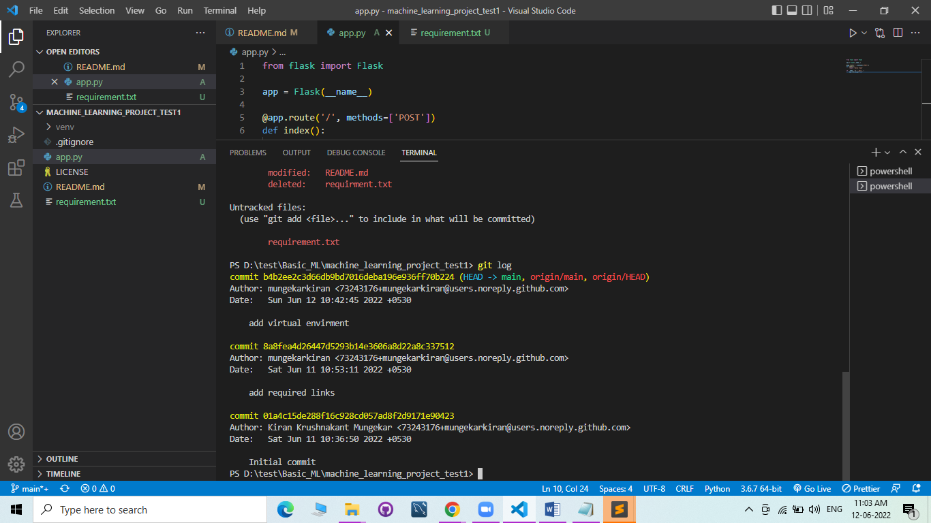

PS D:\test\Basic_ML\machine_learning_project_test1> git remote -v

origin https://github.com/mungekarkiran/machine_learning_project_test1.git (fetch)

origin https://github.com/mungekarkiran/machine_learning_project_test1.git (push)

PS D:\test\Basic_ML\machine_learning_project_test1>

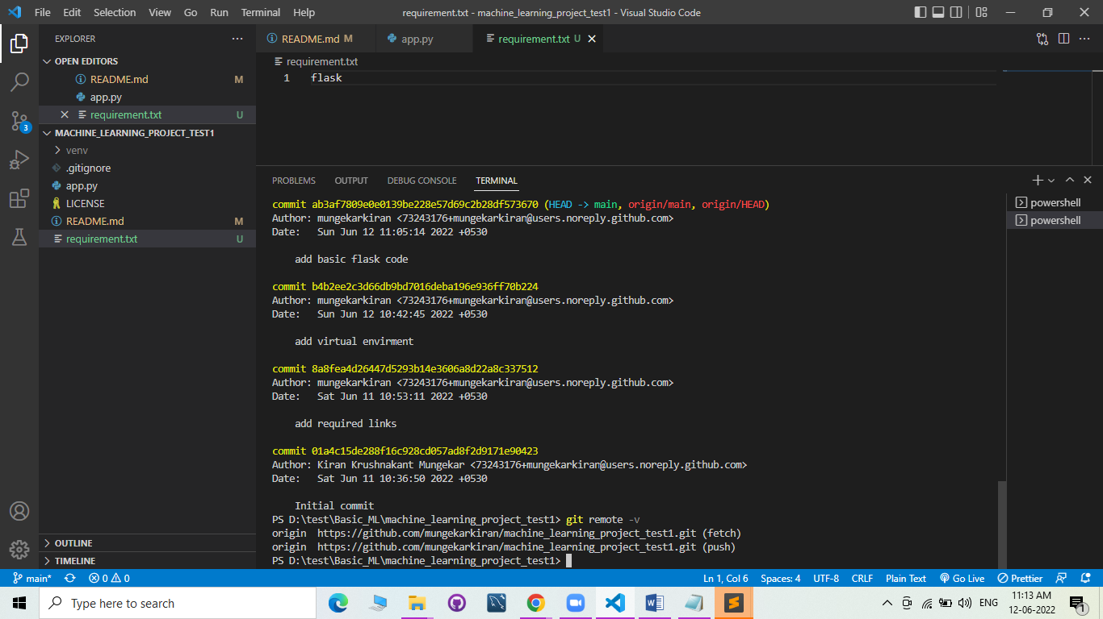

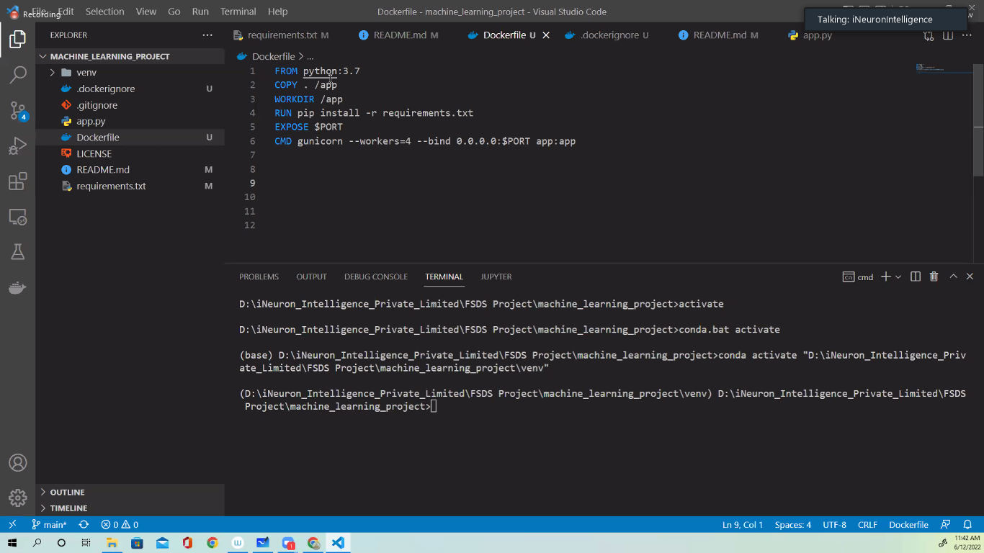

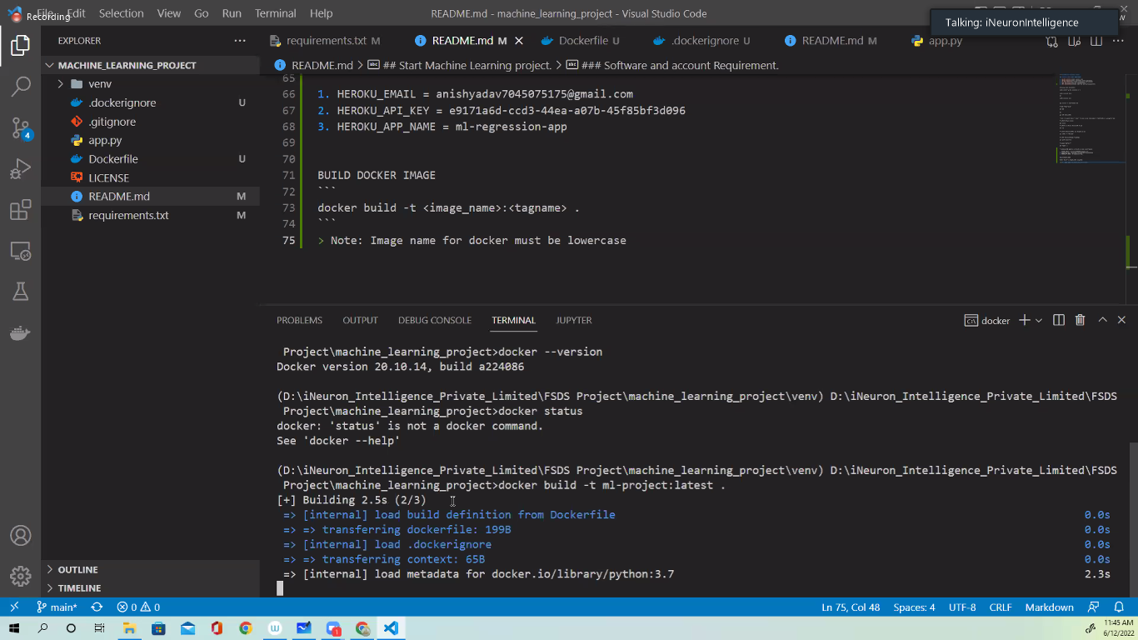

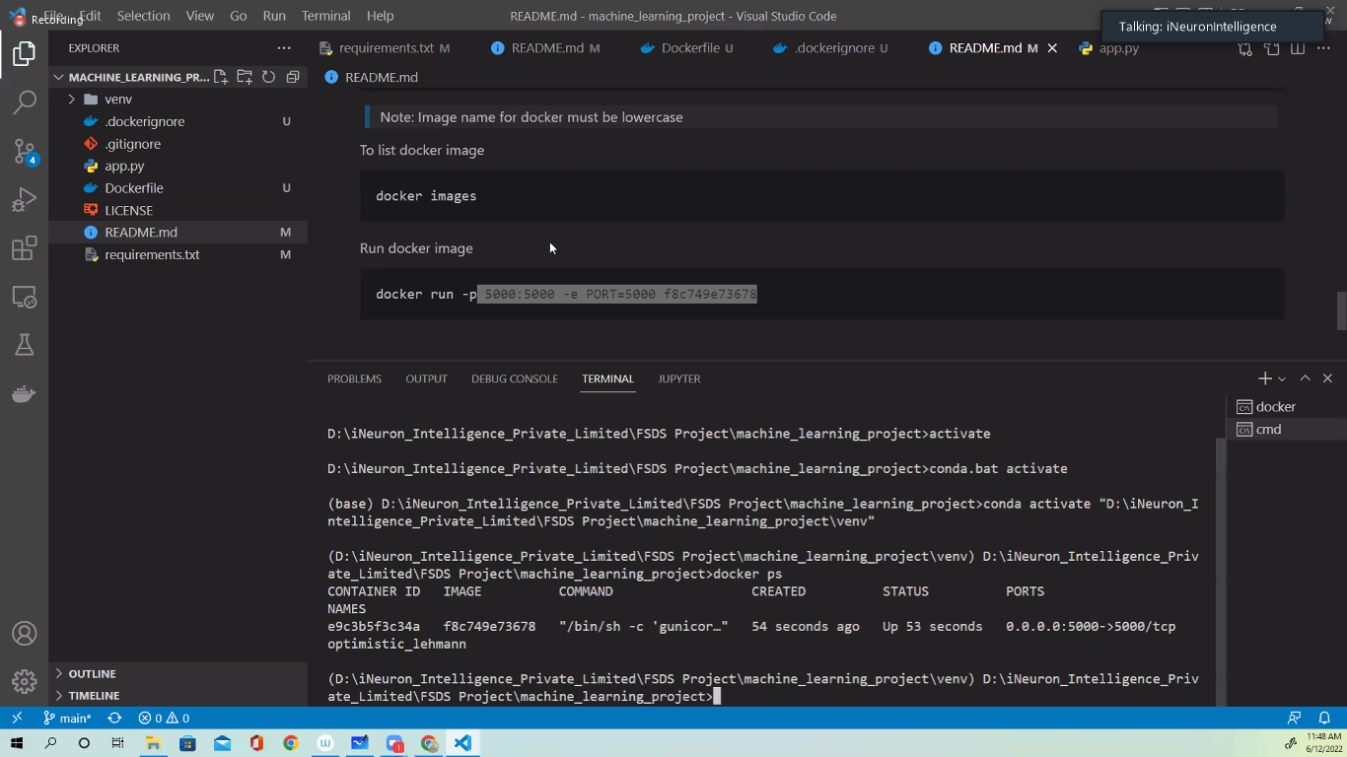 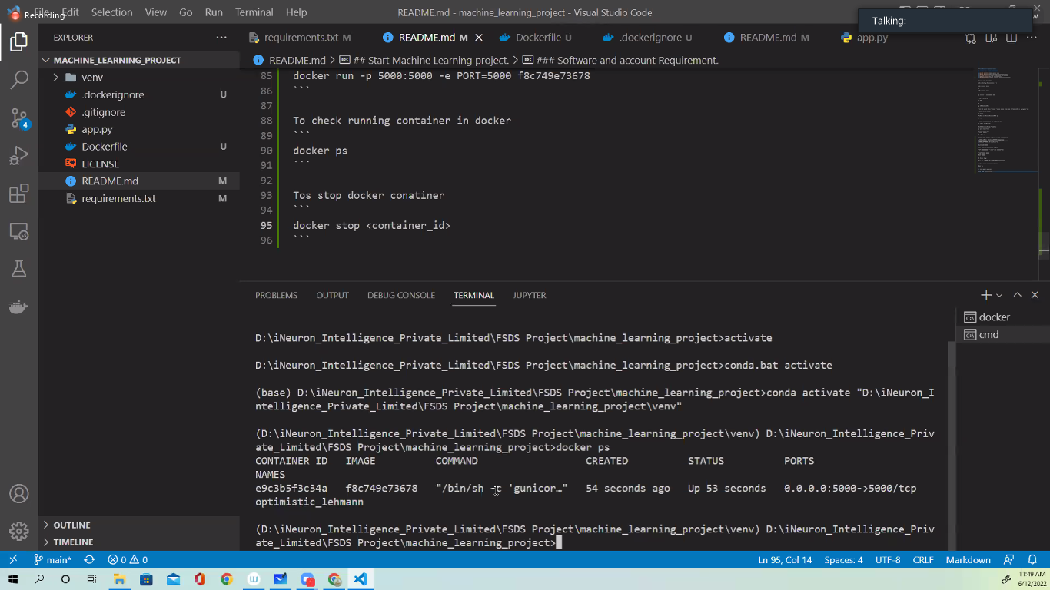

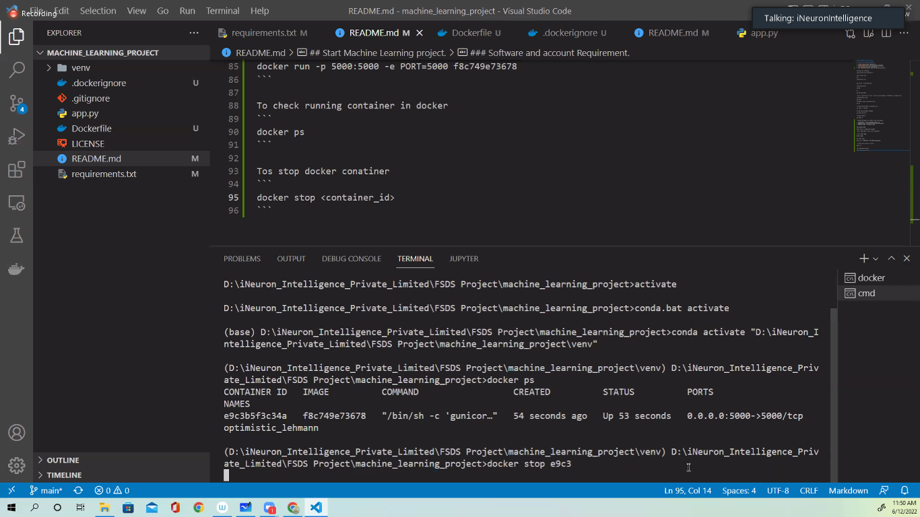

<https://github.com/avnyadav/machine_learning_project>

